CreateADatabaseInCloudantDB

Stepsfollowed:

* LoggedintoIBMCloudaccount
* Navigatedto`./resources`
* Clickedonthe“CreateResource+”button
* Searchedfor“Cloudant”
* Chosethe“LiteVersion”andclickedon“Create”

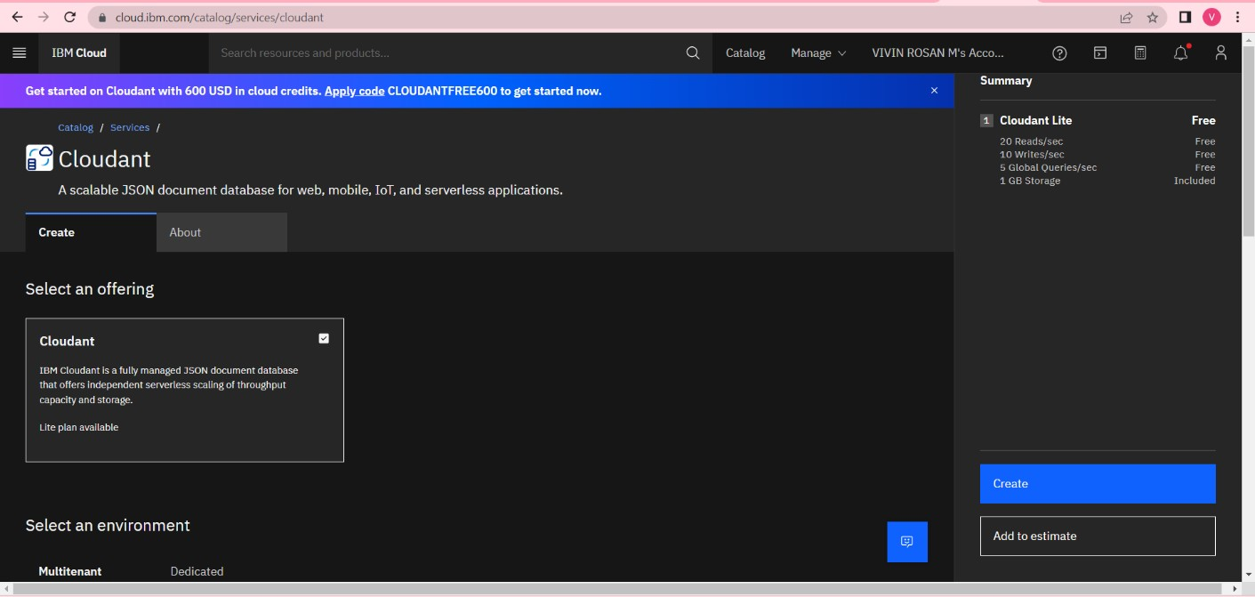

* TheCloudantdatabaseresourcewascreatedsuccessfully

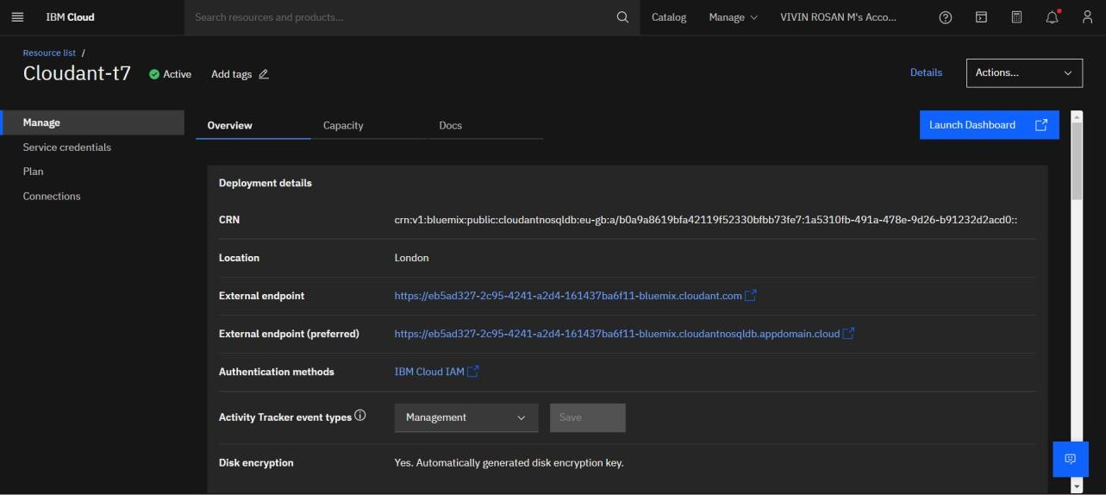

* ClickedonLaunchDashboard

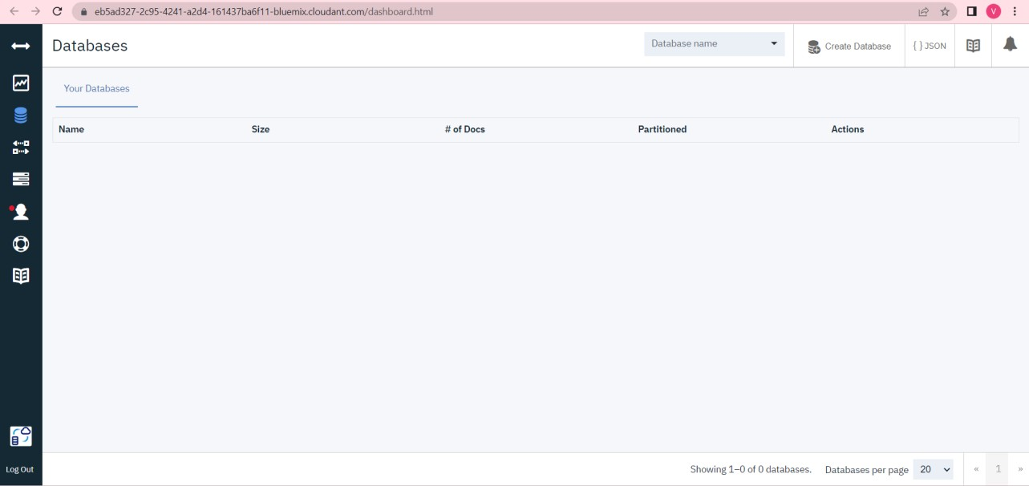

* Clickedon“CreateDatabase”.Entered“meowman”asthedatabasenameandthe“Non-partitioned”option

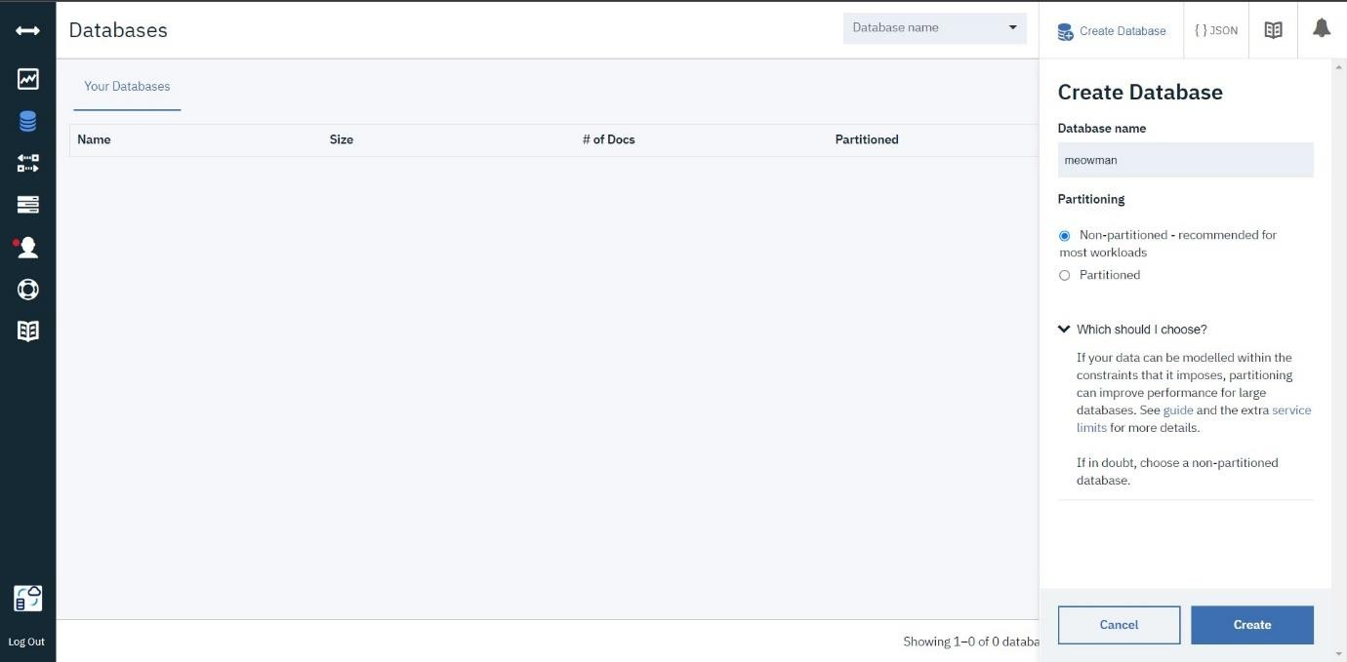

* Thedatabase“meowman”wascreatedsuccessfully

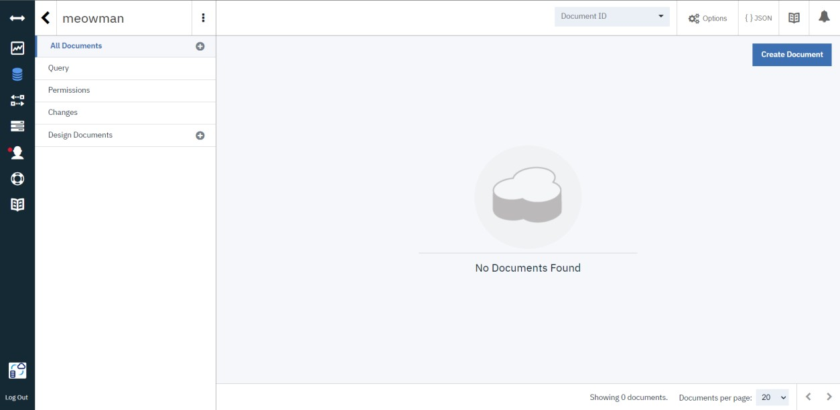

Result:

AdatabasetostorethelocationdatawascreatedsuccessfullyonCloudantDB